**Computational Fluid Dynamics**

**(AE 706)**

**Computer Assignment 3:**

**Unsteady Heat Conduction Problem**

By

Parth Nawkar

210010044



DEPARTMENT OF AEROSPACE ENGINEERING

INDIAN INSTITUTE OF TECHNOLOGY, BOMBAY

Mar, 2024

**Abstract:**

This computer assignment addresses the numerical simulation of an unsteady heat conduction problem through a one-dimensional wall using two different finite-difference schemes: Forward Time Central Space (FTCS) and Crank-Nicolson. The wall, initially at a uniform temperature of 40°C, experiences sudden boundary temperature increases to 200°C at both sides, composed of nickel steel with a diffusivity of α = 2.6 × 10−6 m²/s. The objective is to compute the temperature distribution within the wall over time. The assignment involves determining the stability criteria for the FTCS scheme, comparing the stability and accuracy of both schemes, plotting temperature distributions at various time instances, and evaluating errors compared to the exact solution. General instructions for submission include providing a flowchart, well-documented code, a README file for execution instructions, and a comprehensive report with reproducible plots and comments.

**Problem Statement:**

Consider a wall of (L) 1 m thick and infinite in other directions, as shown in the Figure 1. It has an initial uniform temperature (Ti) of 40o C. The surface temperature (Ts) at the two sides are suddenly raised and maintained Figure 1 at 200 C. The wall is composed of nickel steel with a diffusivity of α = 2.6 × 10−6 m2/s. You need to compute the temperature distribution within the wall as a function of space x and time t. Consider grid size of ∆x = 0.02 for your computations

**Boundary Conditions:**

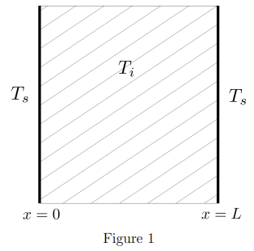

**Governing Equation:**

$$\frac{∂T}{∂t}=α\frac{∂^{2}T}{∂y^{2}}$$

**Implemented Schemes:**

1. FTCS (Forward Time Central Difference):
$$\frac{T_{n+1,i}-T_{n,i}}{Δt}=α⋅\left(\frac{T_{n,i+1}-2T_{n,i}+T_{n,i-1}}{Δx^{2}}\right)$$

2. Crank-Nicolson:

$$\frac{T_{n+1,i}-T_{n,i}}{Δt}=\frac{α}{2}\left[\left(\frac{T_{n+1,i+1}-2T_{n+1,i}+T_{n+1,i-1}}{Δx^{2}}\right)+ \left(\frac{T_{n,i+1}-2T_{n,i}+T_{n,i-1}}{Δx^{2}}\right)\right]$$

**Stable Time Step Calculation for FTCS:**

$$α\frac{Δt}{Δx^{2}}≤\frac{1}{2}$$

$$Δt = \frac{Δx^{2}}{2α}$$

with $Δx = 0.02$, $α=2.6×{10}^{-6}$ results in $Δt ≈76.9$ seconds

**Hence, stable time step of 60 seconds was chosen and**

**for unstable case time step of 100 seconds was used.**

**Exact Solution:**

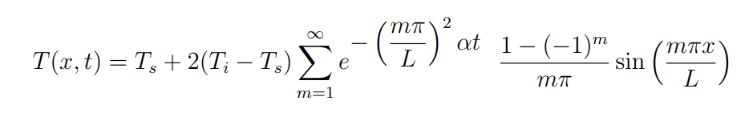

Since taking infinitely many terms isn’t possible, we have considered summation till 100 terms for good enough approximation.

**Results:**

* Comparison Plots (dt = 60 sec):

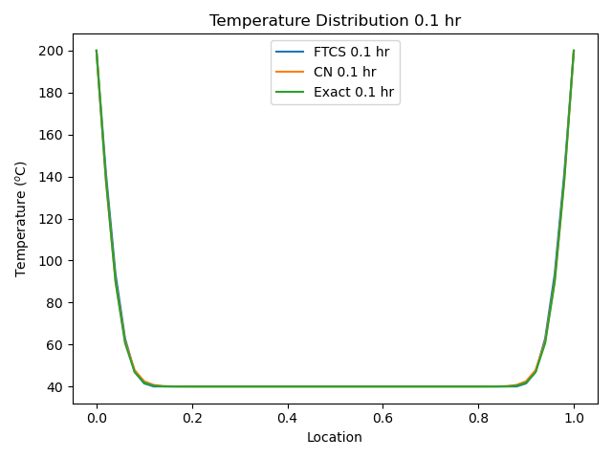

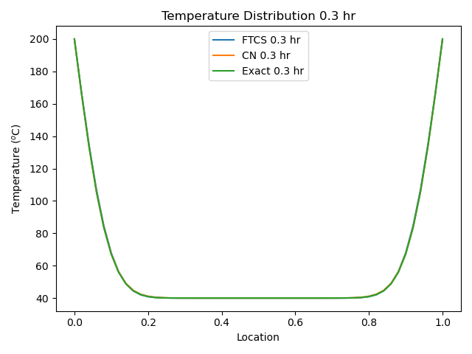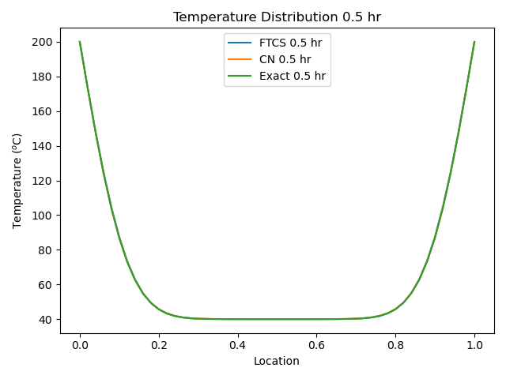

* Unstable FTCS Plots (dt = 100 sec):

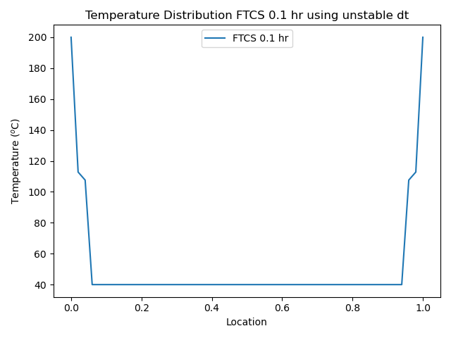

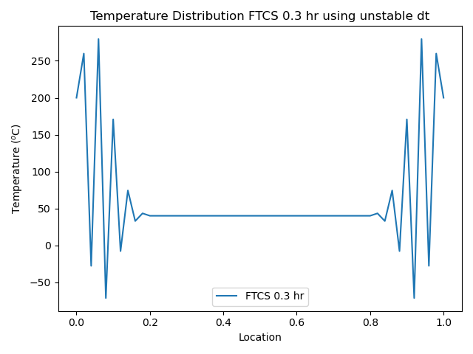

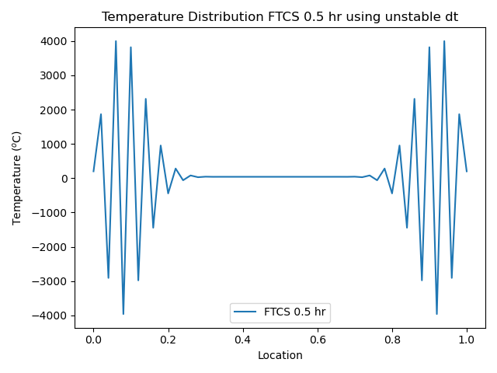

It is evident from the oscillation and abrupt values that the FTCS Scheme is not stable for time step 100 sec (and any dt >76.9 sec) as calculated from equation:

$$Δt = \frac{Δx^{2}}{2α}$$

* **Error Comparison Plots:**

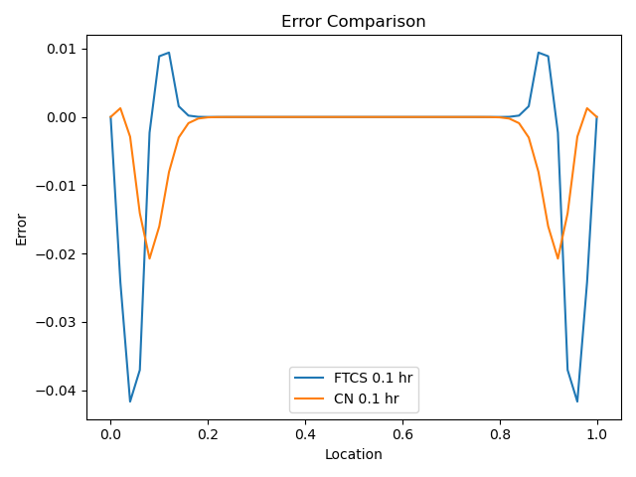

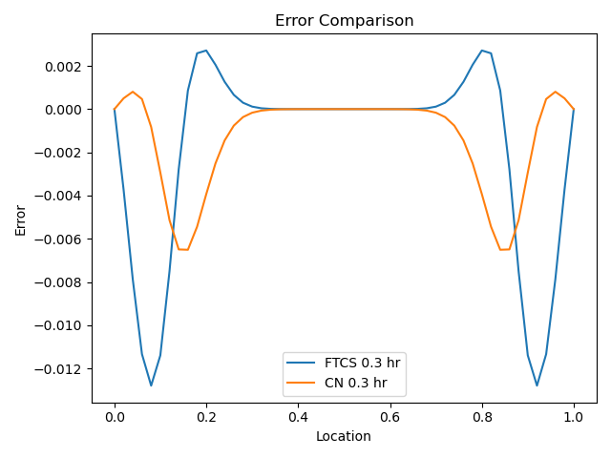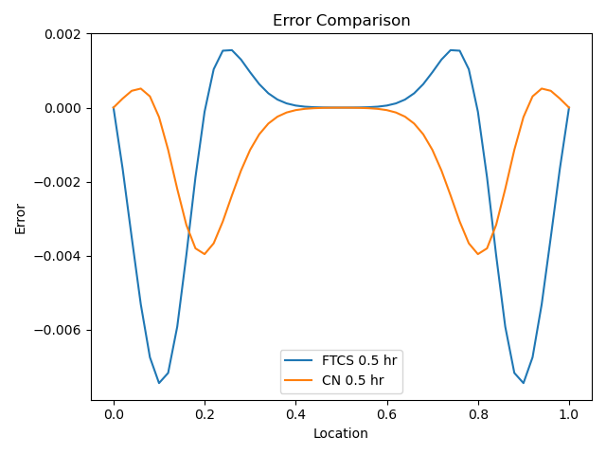

We can observe that Crank-Nicolson Scheme results in lesser error bandwidth in comparison with FTCS for the same parameter (dt, dx, alpha and timesteps).

**Conclusions:**

* Both FTCS and Crank-Nicolson schemes perform well and yield high accuracy (approximately 99 %) in approximating the exact solution.
* In case of FTCS scheme, time step < 76.9 seconds must be chosen to achieve stable results.
* In comparison Crank-Nicolson scheme outputs more precise results than FTCS.

Note:

Flowchart, zip file of code repository and README.txt has been provided with instructions on running the code.